## 2.1 System Level Diagram

The system architecture contains set of sub system, it works together to from a complete system. See figure 1.

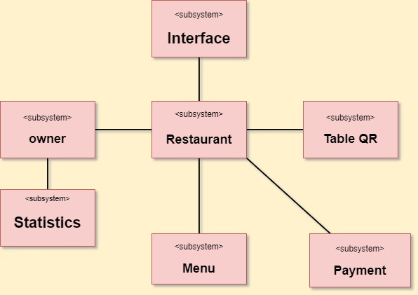

**Fig.1 system Architecture**

Interface: Subsystem interacts with users of different devices using different tools.

Restaurant: The subsystem that contains operations.

Table QR: this subsystem contains QR code for table and operation scan this code to know Who is requesting the service.

Owner: The subsystem is for the owner to modify or add some services to the system.

Statistics: The subsystem is special for the owner to view restaurant information.

Menu: the subsystem to View all food served by the restaurant with its price.

Payment: the subsystem to Pay customer bills safely.